Site plan of Lawnsmead -
This is a concept drawing showing the layout of potentially four terraced cottages in place of the existing hall. They are aligned to look out over the common to move them further away from the nearby Lawnsmead cottages, to adapt most suitably with the site and to provide adequate parking.
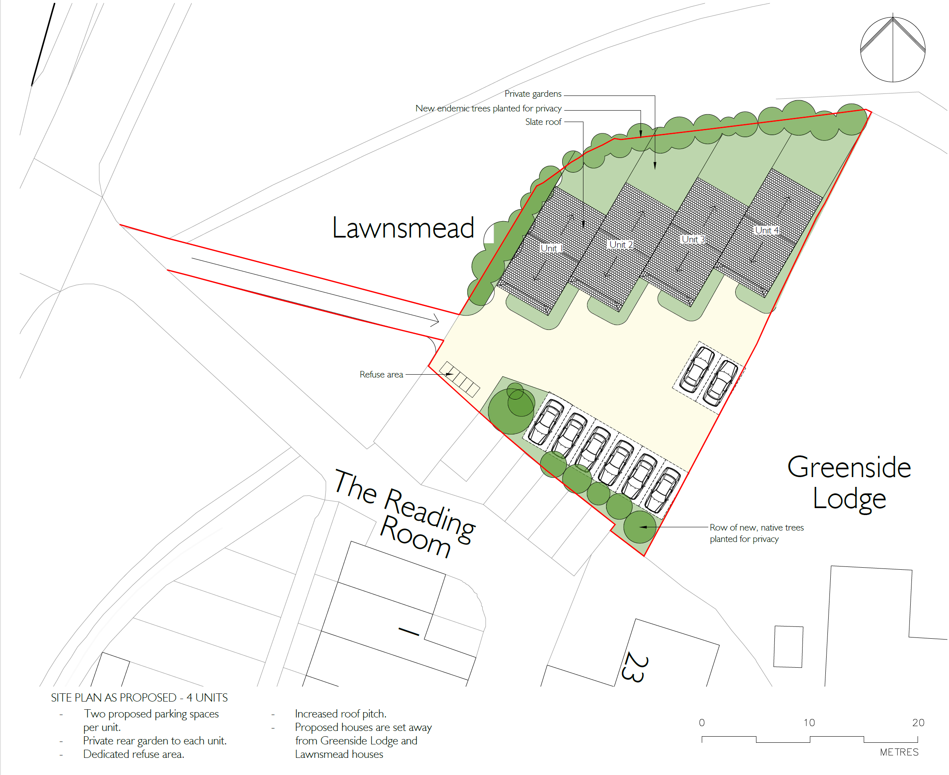

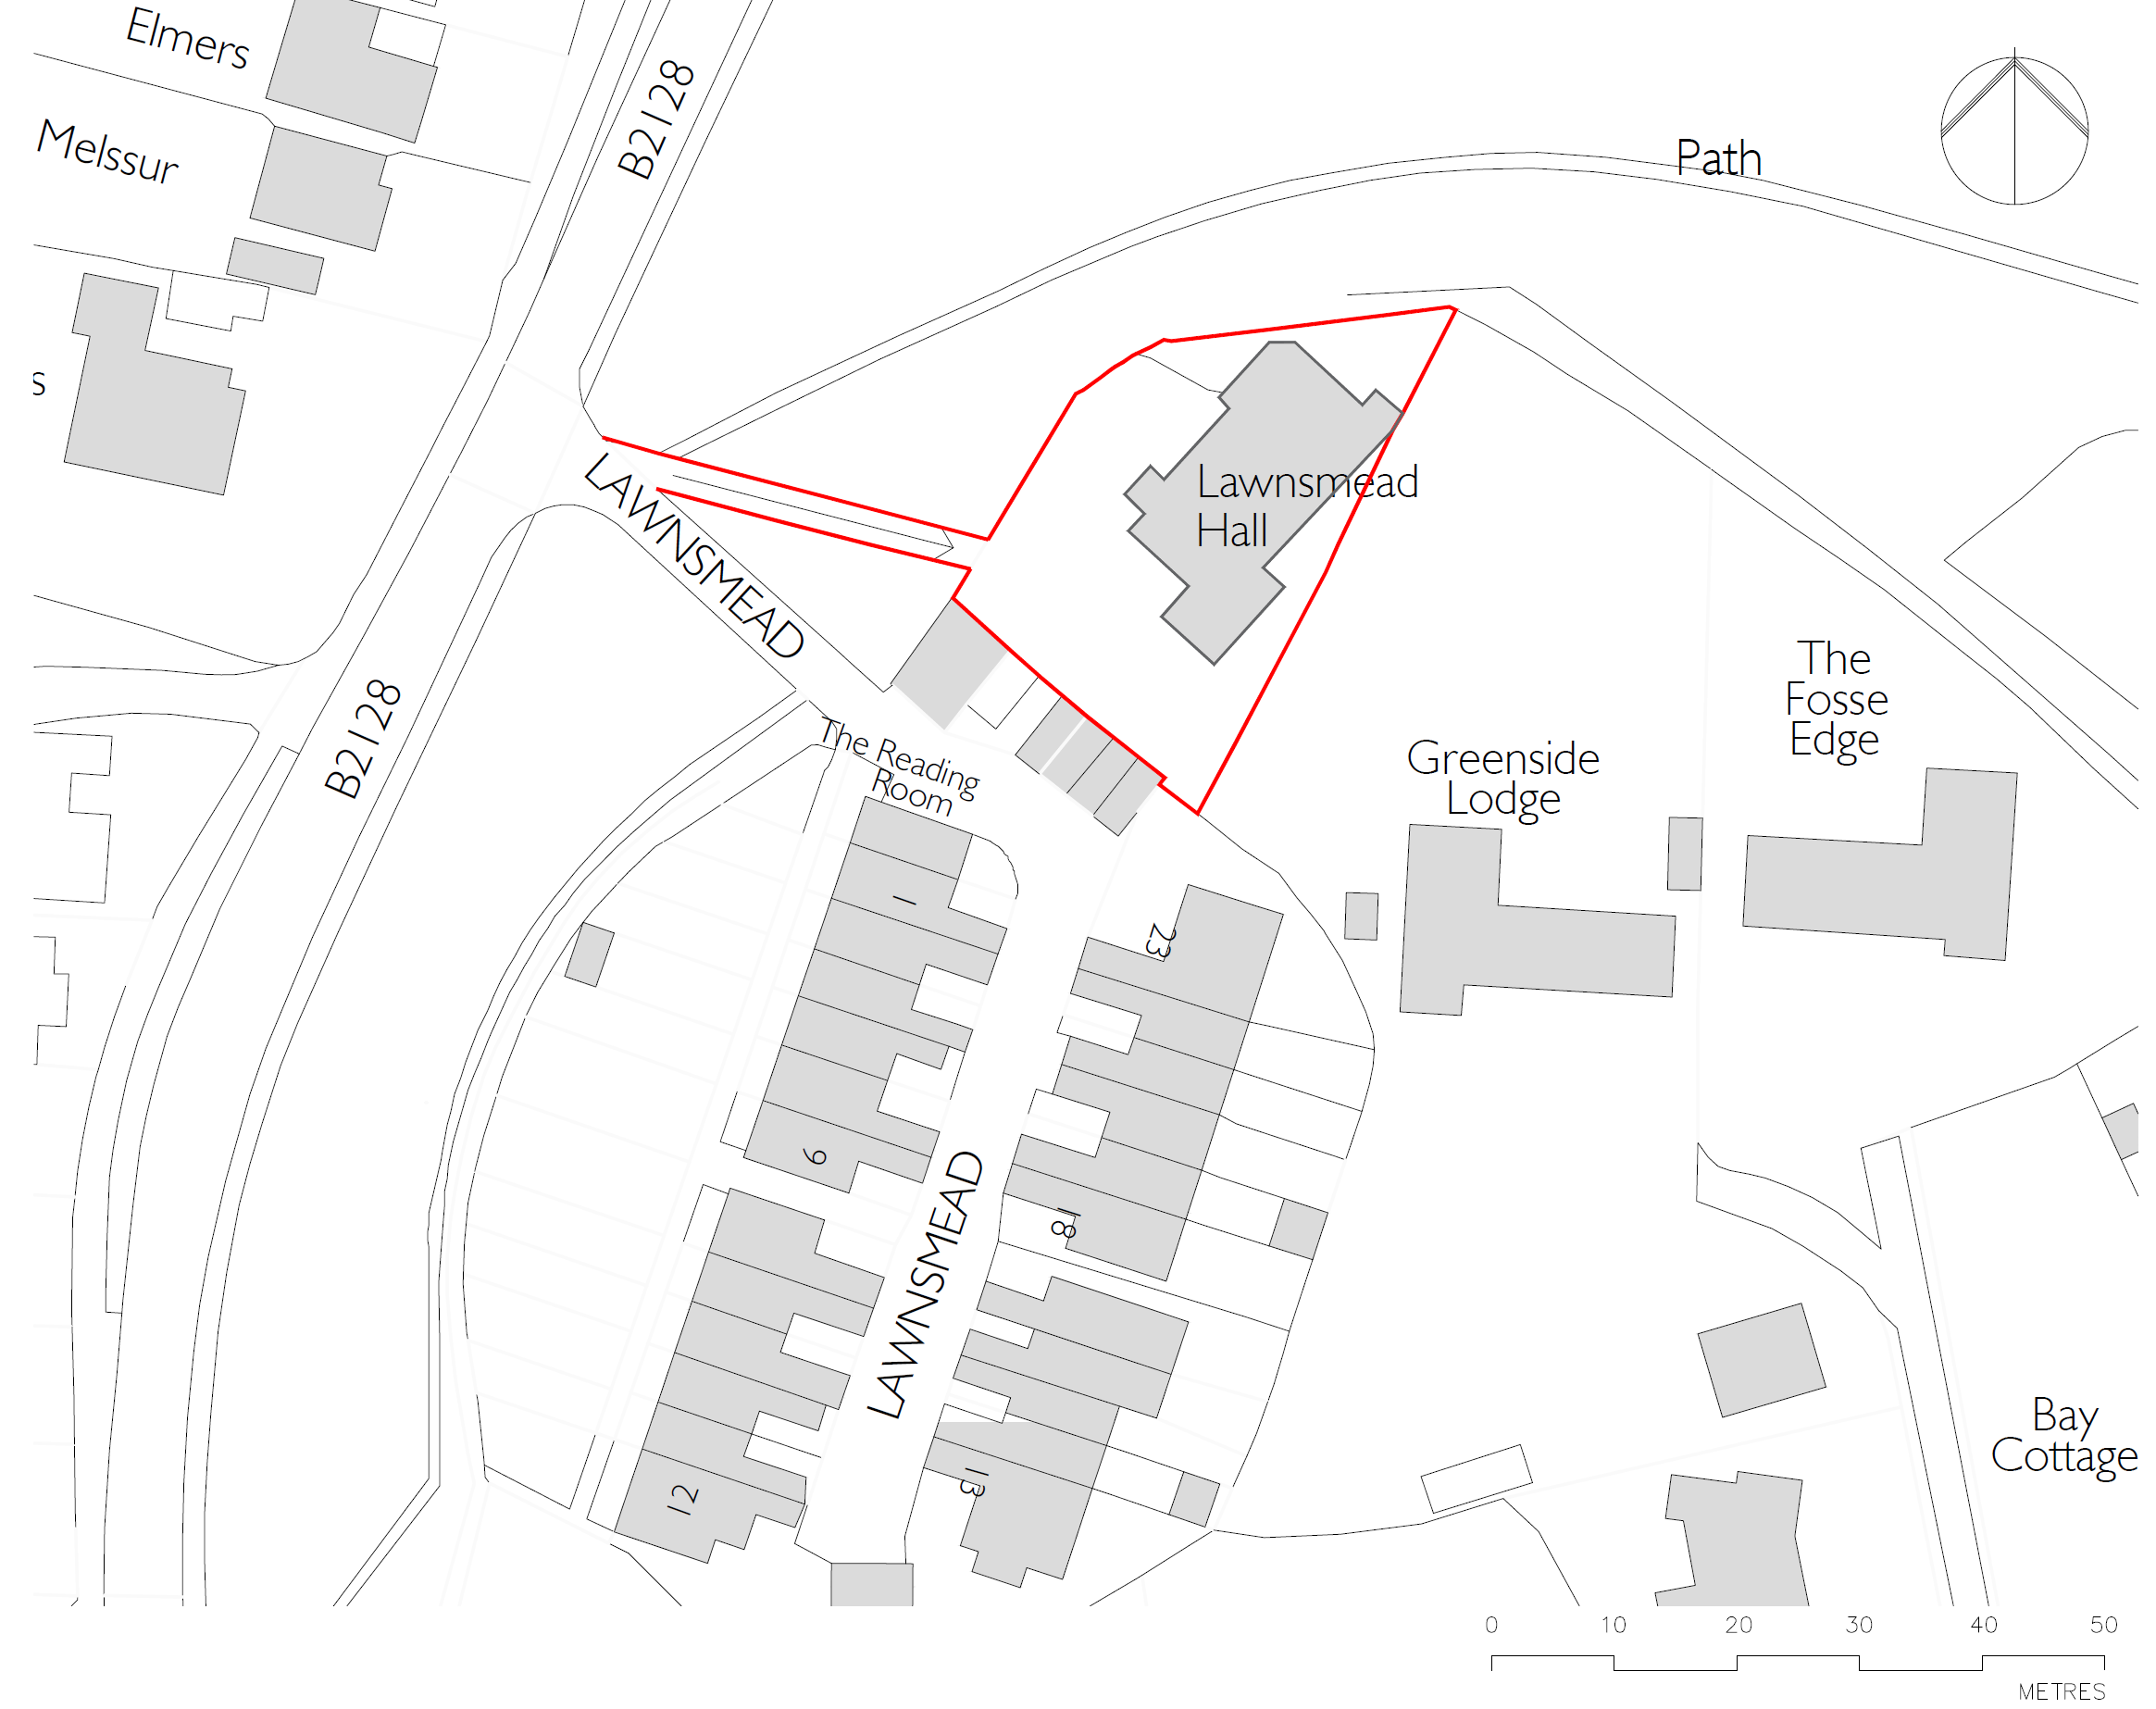
Plan of the new cottages -
This shows ground and first floor plans for the cottages on the Lawnsmead Hall site. The intention is to ensure that the design of the cottages is in keeping with surrounding housing stock but this will only be finalised once planning permission is granted.
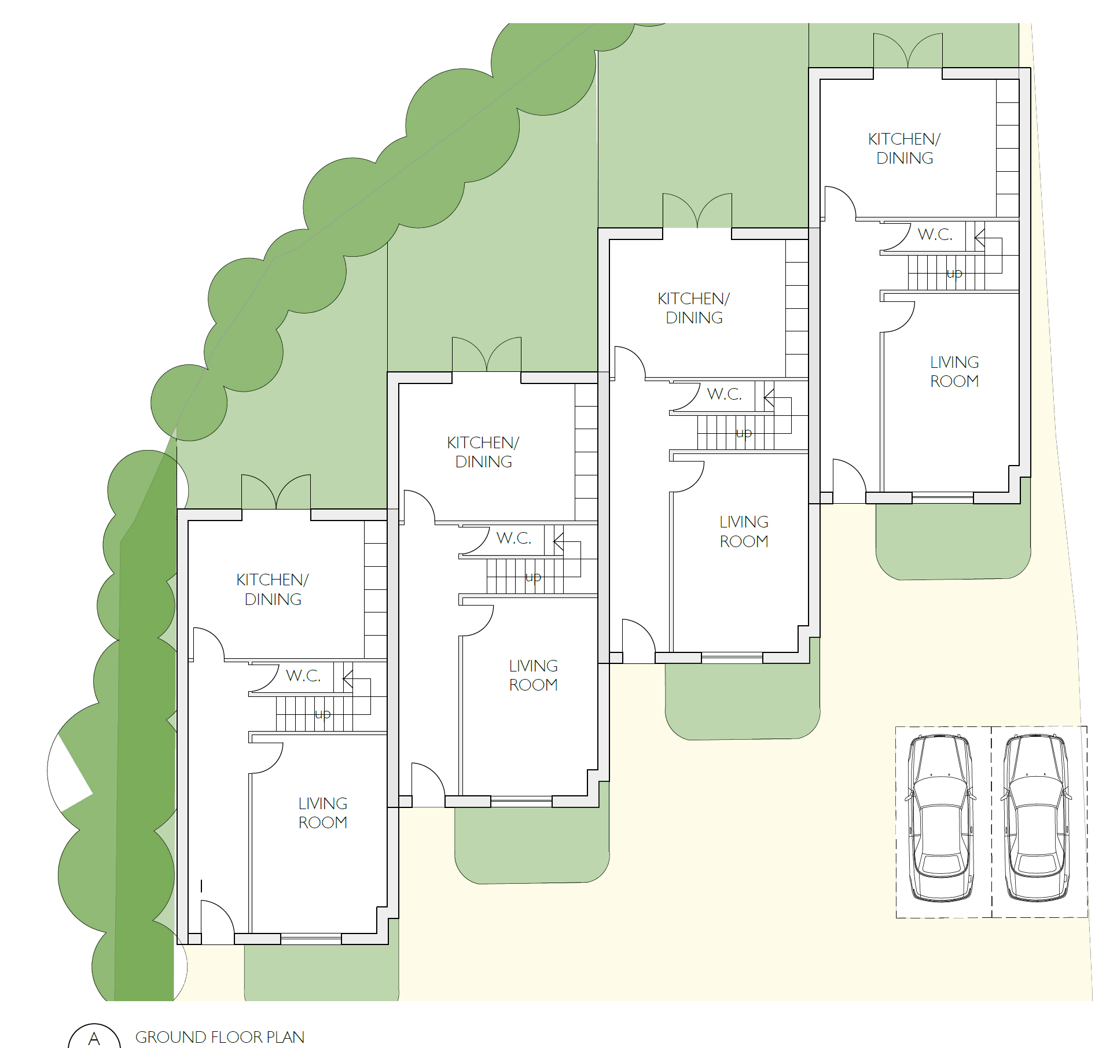
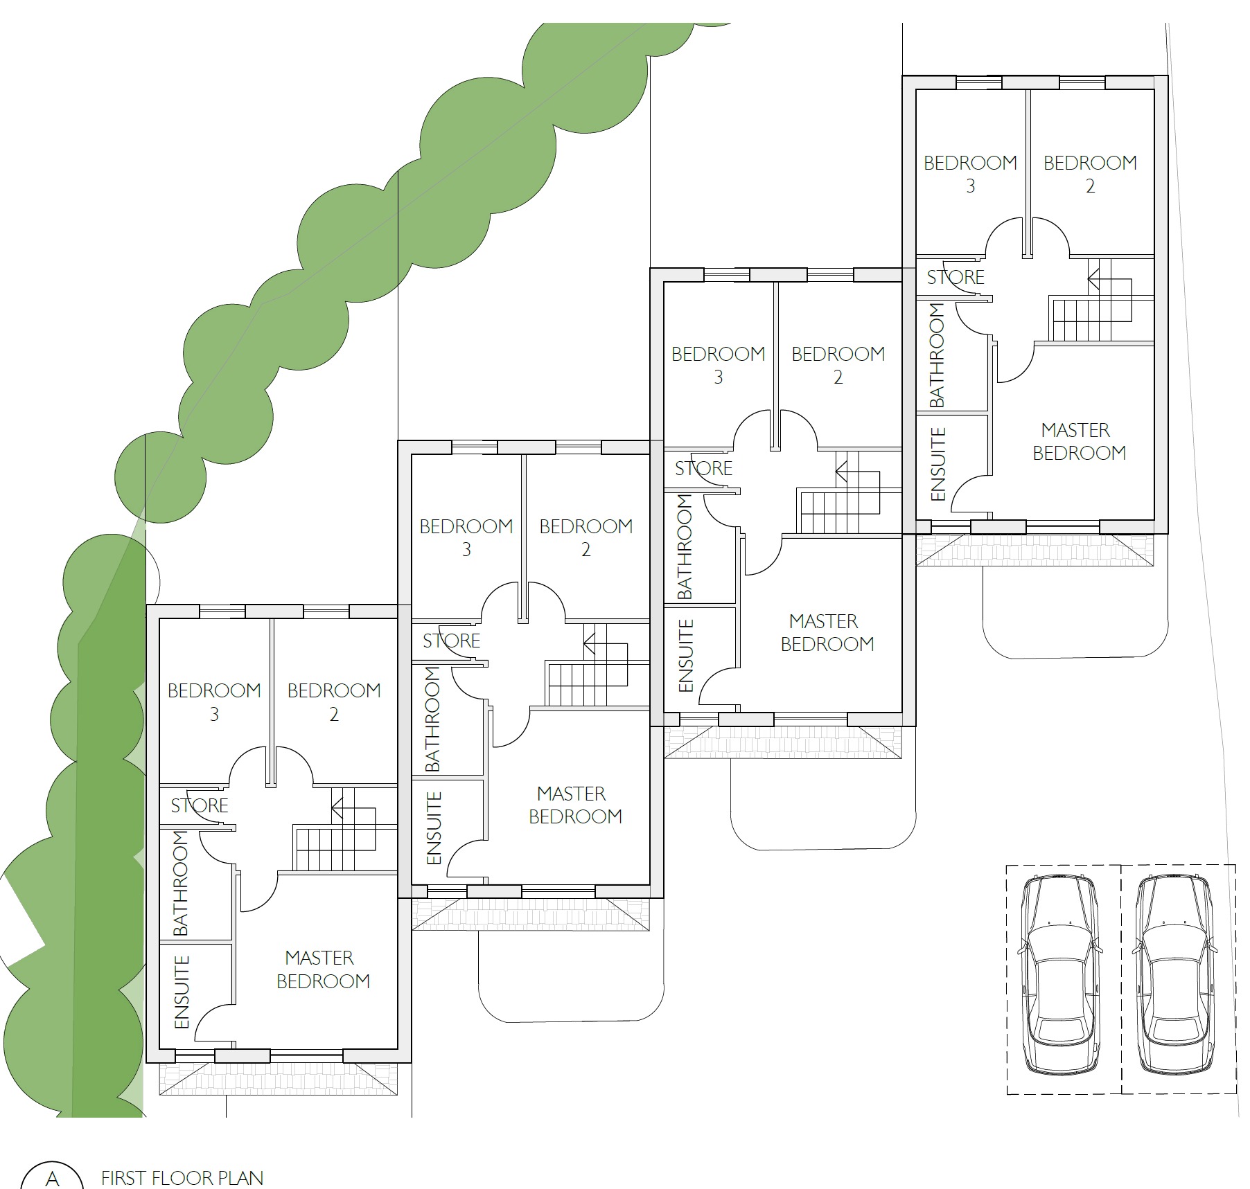
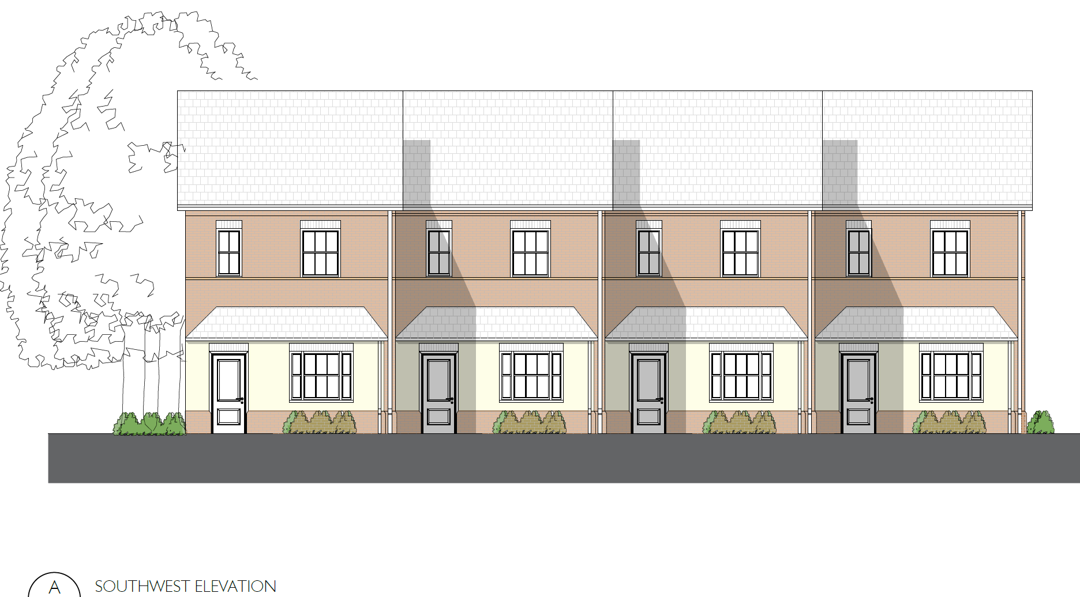
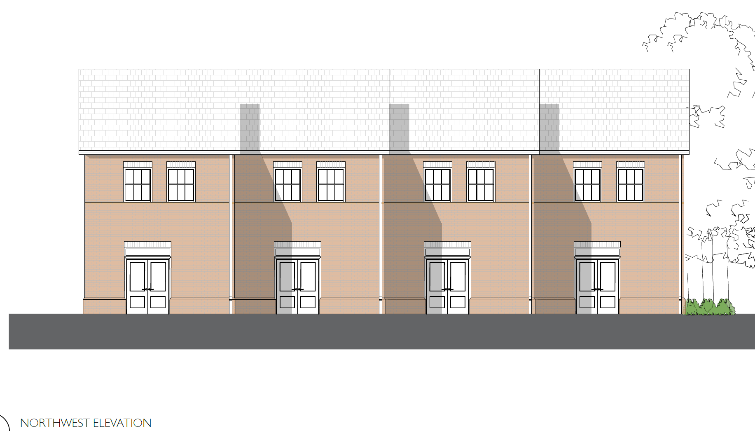

Site plan of the church/churchyard and new hall -
This plan shows the relative positioning of an extension to the existing church extension along with a new hall in the churchyard grounds as a replacement of Lawnsmead. The hall would be of similar size to the main hall but the smaller rooms in the church could be used at the same time, while providing privacy and separation for each. While there is more suitable parking on site at the church, there may be a need to create some additional spaces.
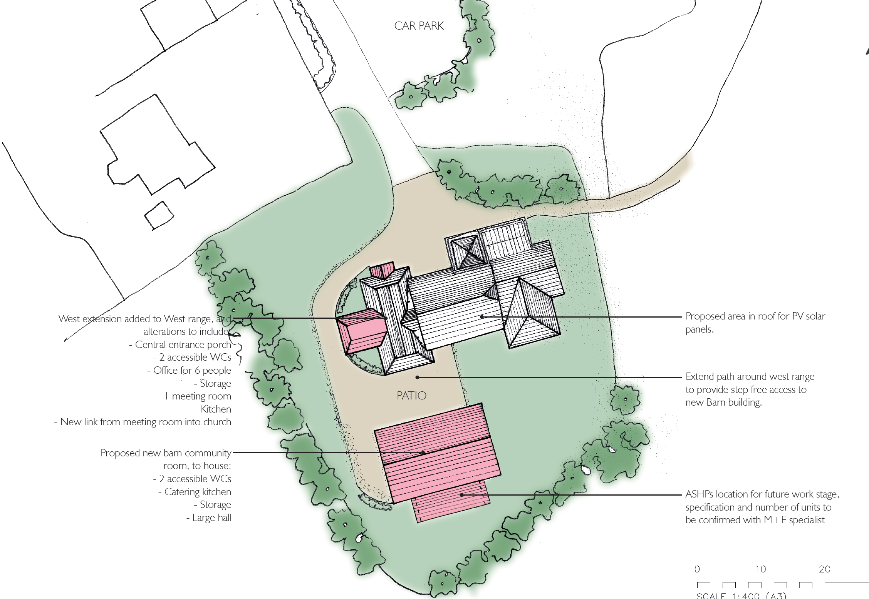
Floor plan of the church and amended extension -
This shows the intended layout of the church and extension illustrating the enlarged office, better WC facilities, two separate rooms and improved access into the church. With underfloor heating and PV panels on the roof, this could be a sustainable building with the Nave of the church used as a flexible space if pews were removed (but retained in smaller form in the Lady Chapel).
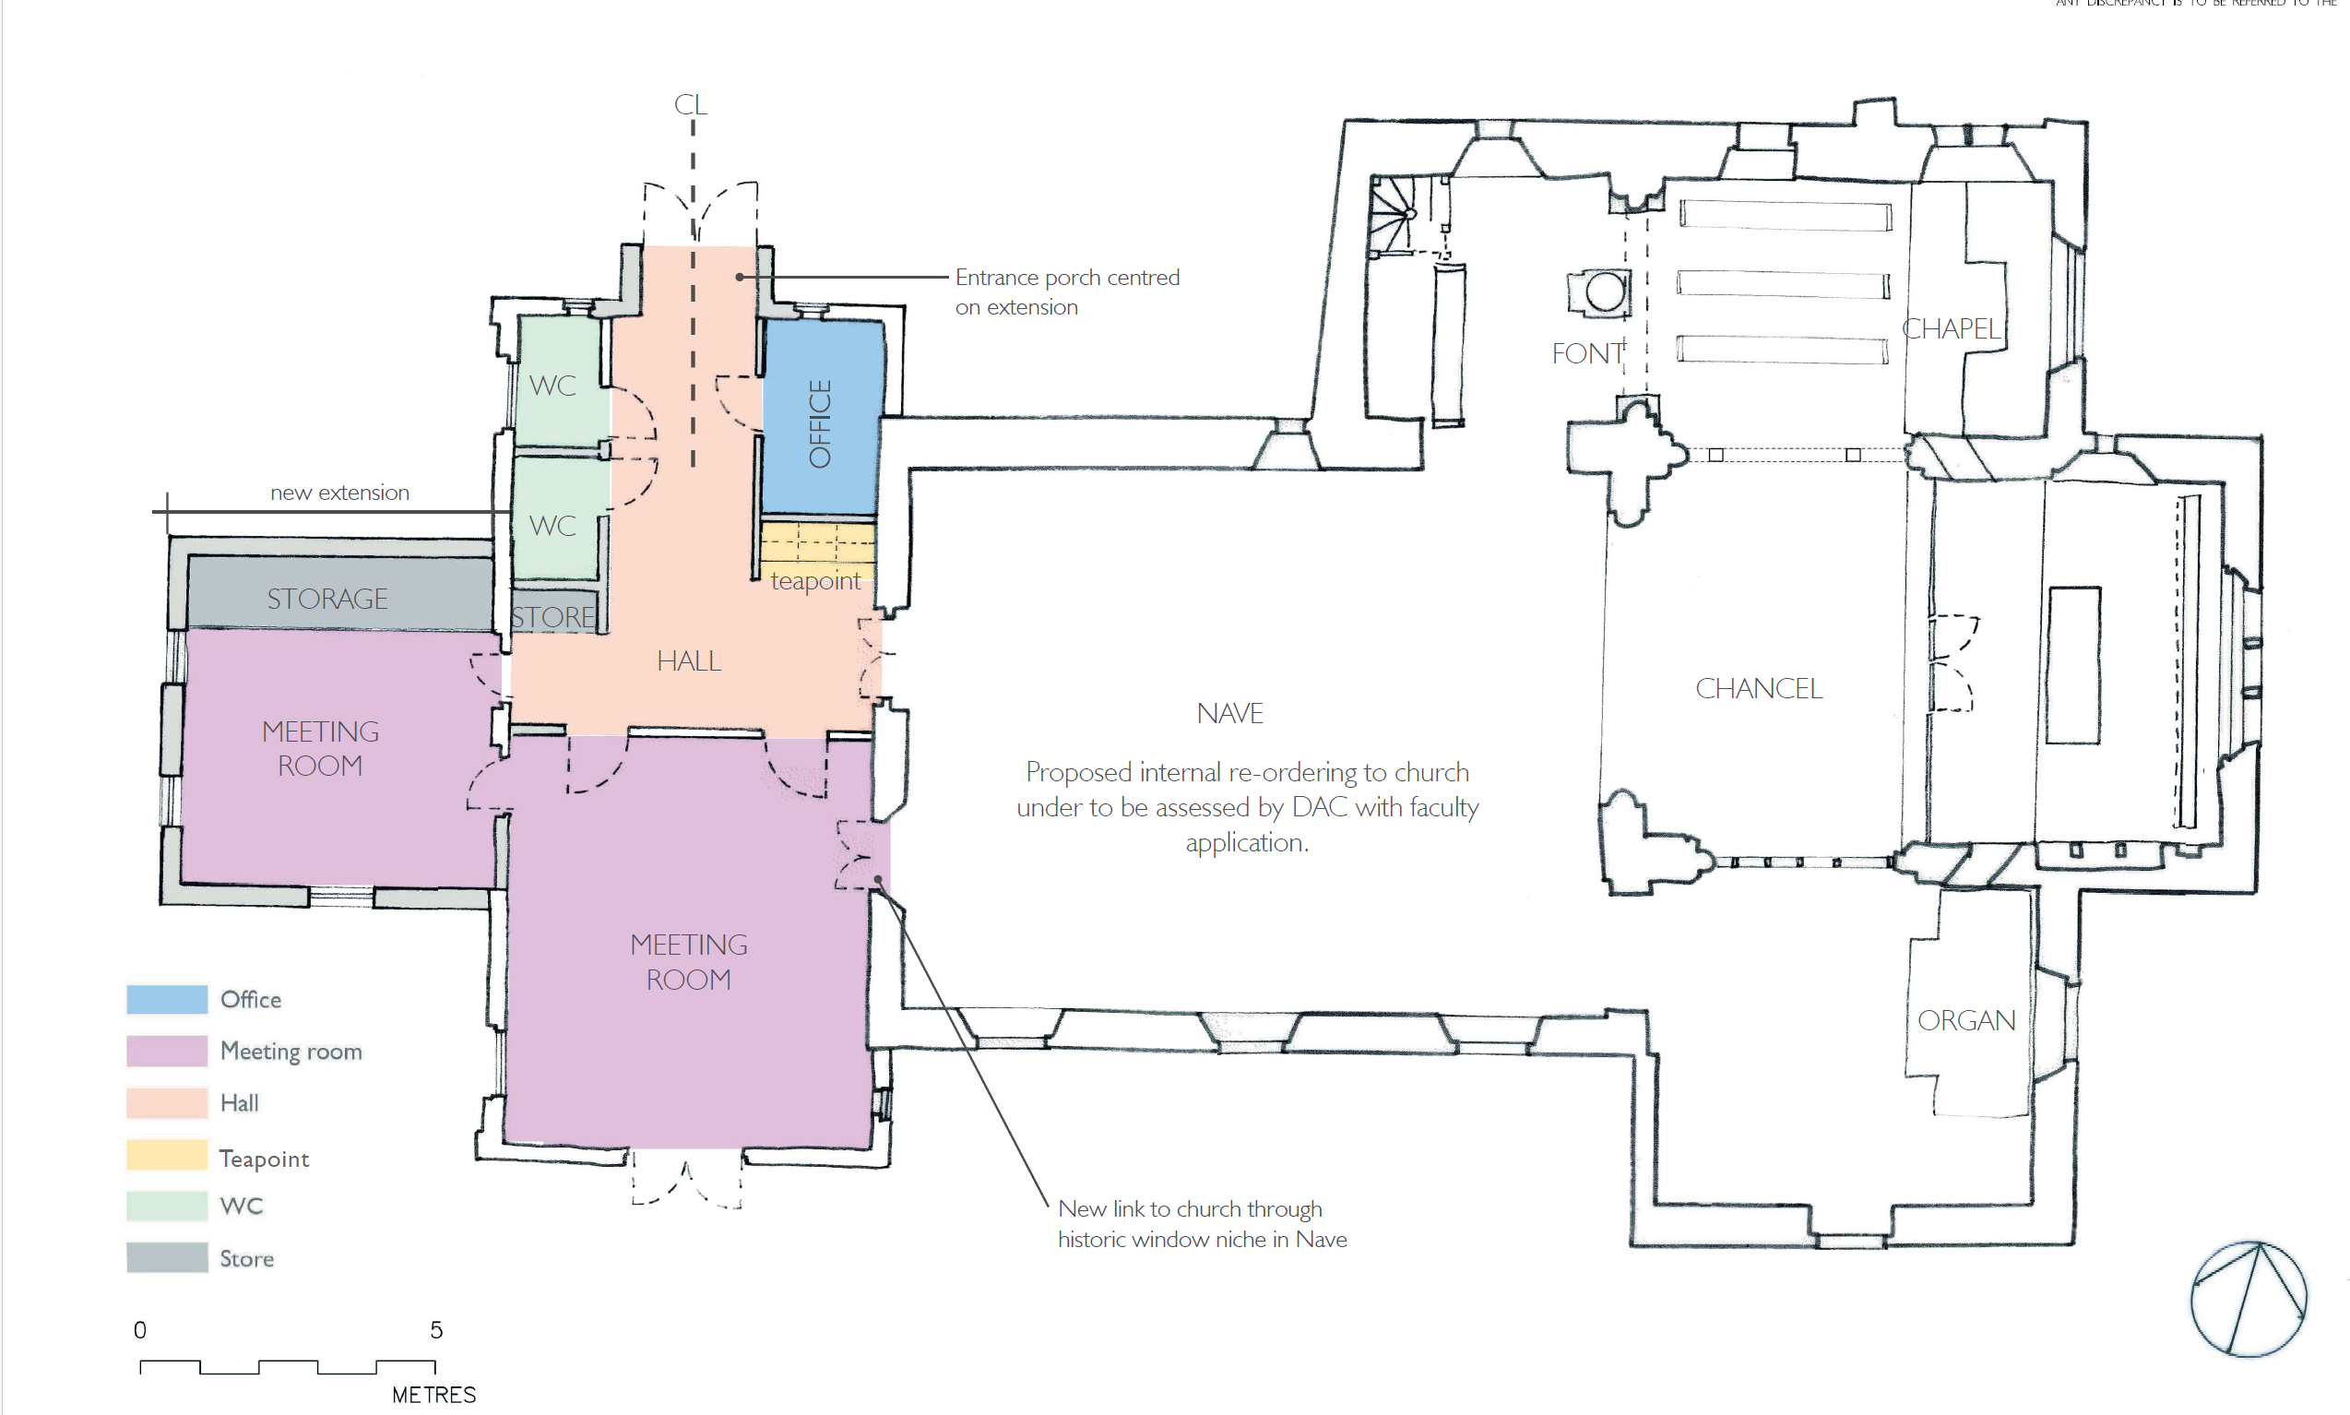
Floor plan of the new hall -
This plan shows the general layout of the new hall incorporating separate WC's, a commercial kitchen, storage and the main hall. Either an inbuilt screen or free-standing options could divide this space if more intimate areas were required. The building would be separated from the church by a terrace area for standing receptions/ greeting space. Development would be in conjunction with a archaeologist to ensure any remains are reinterred or as much as possible, left undisturbed. There are few headstones in the area concerned but any affected would be cleaned and placed elsewhere in the churchyard (as occurred for the previous extension).
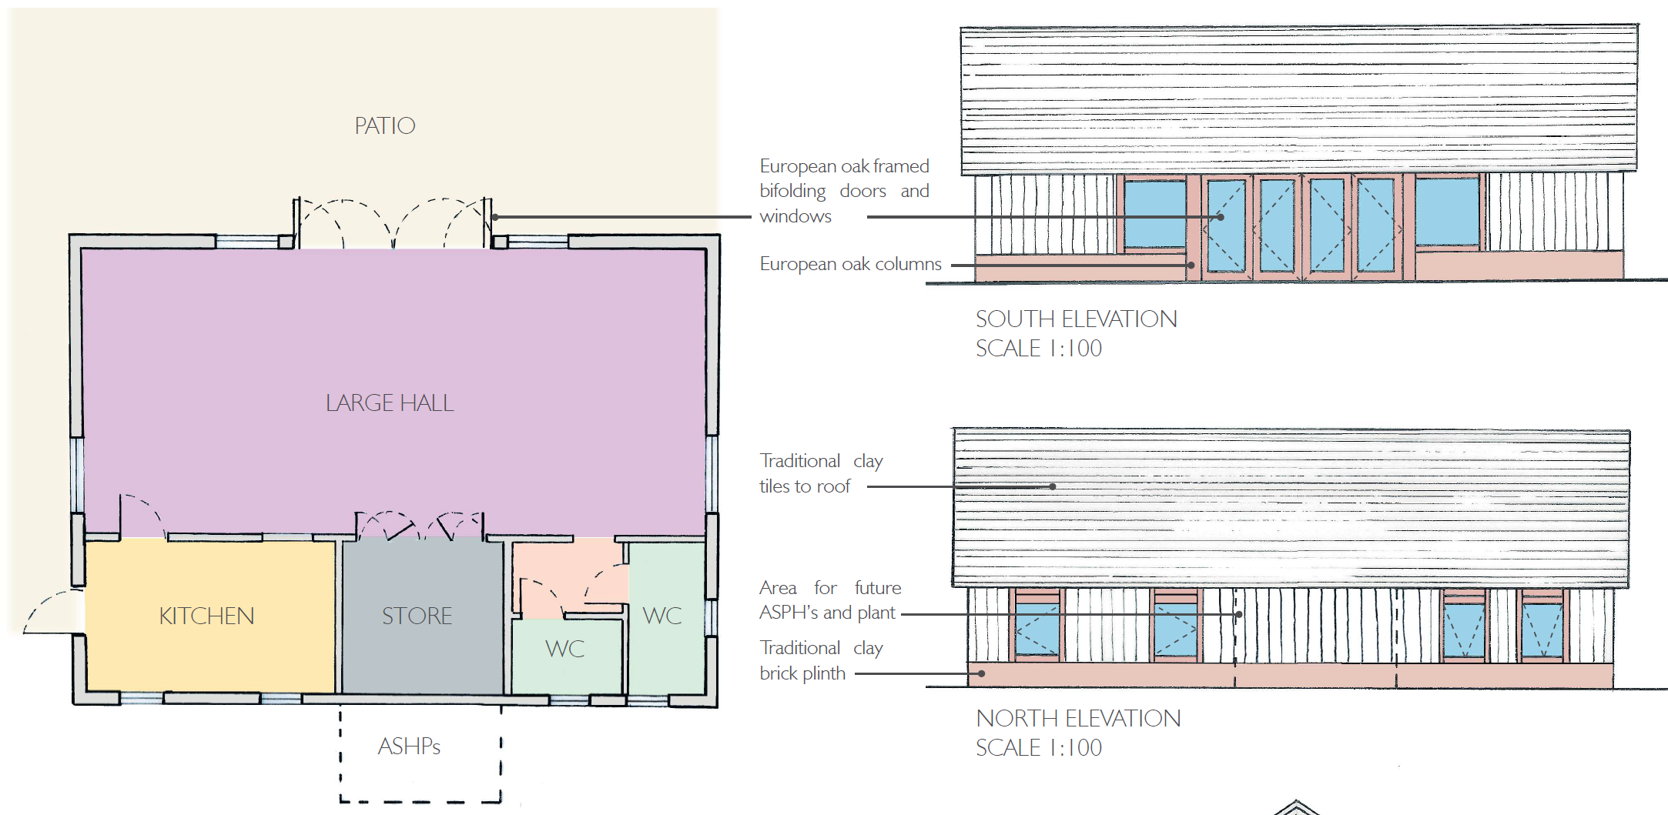
Artistic design of the site -
This drawing shows the potential visual of the church/extension/hall as it might appear from the vicarage perspective.

